Week 2 module 5 task 1

Install Zenmap

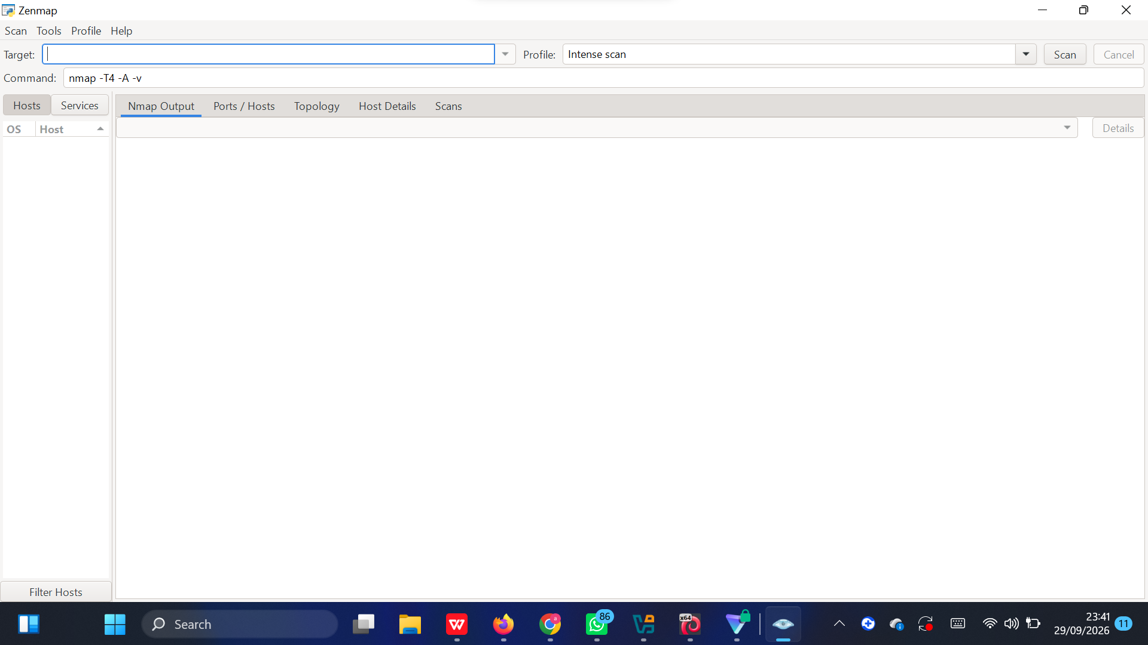

TAsk 2

Ethernet adapter vEthernet (Default Switch):

Connection-specific DNS Suffix . :
Link-local IPv6 Address . . . . . : fe80::b20a:b545:b8eb:da7a%11
IPv4 Address. . . . . . . . . . . : 172.23.0.1
Subnet Mask . . . . . . . . . . . : 255.255.240.0
Default Gateway . . . . . . . . . :

Ethernet adapter Ethernet:

Connection-specific DNS Suffix . :
IPv4 Address. . . . . . . . . . . : 192.168.56.1
Subnet Mask . . . . . . . . . . . : 255.255.255.0
Default Gateway . . . . . . . . . :

Ethernet adapter Ethernet 2:

Connection-specific DNS Suffix . :
IPv4 Address. . . . . . . . . . . : 192.168.123.1
Subnet Mask . . . . . . . . . . . : 255.255.255.0
Default Gateway . . . . . . . . . :

Unknown adapter Local Area Connection:

Media State . . . . . . . . . . . : Media disconnected
Connection-specific DNS Suffix . :

Wireless LAN adapter Local Area Connection* 1:

Media State . . . . . . . . . . . : Media disconnected
Connection-specific DNS Suffix . :

Wireless LAN adapter Local Area Connection* 12:

Media State . . . . . . . . . . . : Media disconnected
Connection-specific DNS Suffix . :

Wireless LAN adapter Wi-Fi:

Connection-specific DNS Suffix . :
IPv4 Address. . . . . . . . . . . : 192.168.1.6
Subnet Mask . . . . . . . . . . . : 255.255.255.0
Default Gateway . . . . . . . . . : 192.168.1.1

Ethernet adapter Bluetooth Network Connection:

Media State . . . . . . . . . . . : Media disconnected
Connection-specific DNS Suffix . :

Ethernet adapter vEthernet (WSL):

Connection-specific DNS Suffix . :
Link-local IPv6 Address . . . . . : fe80::c2f5:f34f:2dcf:c02b%76
IPv4 Address. . . . . . . . . . . : 172.28.144.1
Subnet Mask . . . . . . . . . . . : 255.255.240.0
Default Gateway . . . . . . . . . :

Wireless LAN adapter Wi-Fi:
- IPv4 Address: 192.168.1.6
- Subnet Mask: 255.255.255.0
- Default Gateway: 192.168.1.1
Task 3

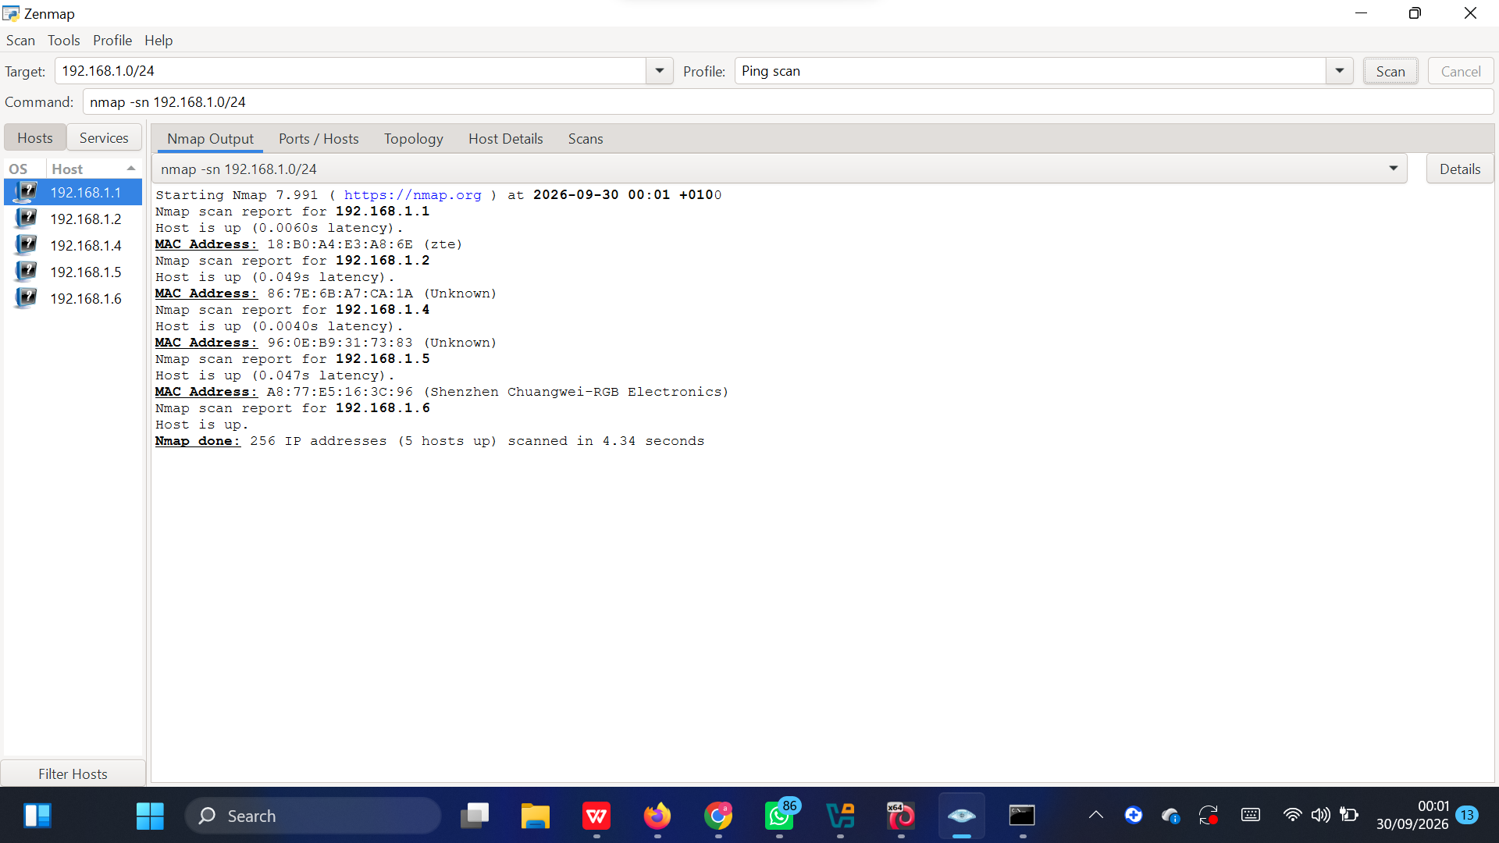

Task 4
5 hosts are live- Nmap done: 256 IP addresses (5 hosts up) scanned in 4.34 seconds

Task 5: The IP addresses of the live hosts
- 192.168.*.*
- 192.168.*.*
- 192.168.*.*
- 192.168.*.*
- 192.***.*.*

Task 6: The MAC addresses of the live hosts?
- 18:B0:**:**:**:** (zte — likely your router/modem)
- 86:7E:6B:A7:**:** (Unknown vendor)
- 96:0E:B9:31:**:** (Unknown vendor)
- A8:77:E5:16:**:** (Shenzhen Chuangwei-RGB Electronics)
- Your own PC (192.***.*.*) doesn't show a MAC here since Nmap can't get your own machine's MAC over the network — run ipconfig /all in Command Prompt and look for "Physical Address" under the Wi-Fi adapter to get that one.

Task 7
